NAMA KEDAI | GAMBAR CENDERAMATA | HARGA | LOKASI
LADIARA SIGNATURE | 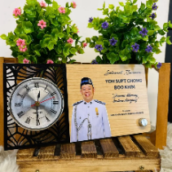  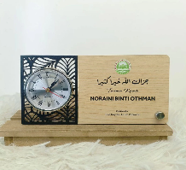 | RM 45.00  Ada gambar  RM 41.00  Tiada gambar | Shoppee Malaysia  Ladiara Signature
LADIARA SIGNATURE | 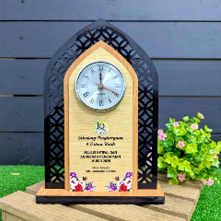 | RM 59.00 | Shoppee Malaysia  Ladiara Signature
LADIARA SIGNATURE | 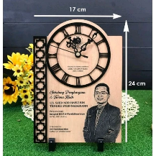 | RM 66.00 | Shoppee Malaysia  Ladiara Signature
LADIARA SIGNATURE | 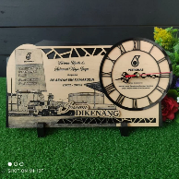 | RM 65.00 | Shoppee Malaysia  Ladiara Signature

Kalau dah confirm payment, pihak kedai akan sediakan design.

